

NC Project Report:

Numerical methods for solving system of Nonlinear Equations

By: Sheikh Alyan 11891

Abstract:

This report explores the application of nonlinear algebraic equations in mathematical modeling. Nonlinear algebraic equations are equations in which the variables are raised to a power other than one or involve products of variables. These equations are fundamental in various scientific and engineering disciplines because they can model complex systems and phenomena that cannot be represented by linear equations.

The report begins with a discussion of the theoretical background of nonlinear equations, providing an overview of their characteristics and importance in mathematical modeling. We delve into the nature of nonlinear systems, highlighting the challenges associated with solving these equations analytically. Unlike linear equations, which can be solved using straightforward algebraic techniques, nonlinear equations often require iterative numerical methods to find approximate solutions.

We then present practical examples where nonlinear algebraic equations are utilized to solve real-world problems. These examples are drawn from diverse fields such as physics, engineering, economics, and biology, demonstrating the wide-ranging applicability of nonlinear equations. For instance, in physics, nonlinear equations are used to model the behavior of complex systems such as chaotic systems and wave propagation. In engineering, they are essential for designing and analyzing systems like electrical circuits and structural components that exhibit nonlinear behavior.

The report includes detailed mathematical formulations of these real-world problems, illustrating how nonlinear equations are derived and structured. We explore various types of nonlinear equations, including polynomial equations, transcendental equations, and systems of nonlinear equations. Each type is examined with respect to its unique properties and the specific methods required for its solution.

Numerical methods for solving nonlinear equations are a central focus of this report. We discuss several widely used techniques, such as the Newton-Raphson method, the bisection method, and the secant method. Each method is explained in detail, with step-by-step procedures and mathematical justifications. The advantages and limitations of each method are also considered, helping readers understand when and how to apply these techniques effectively.

To provide practical insights, the report includes implementation examples in MATLAB and Python. These programming languages are chosen for their powerful numerical computation capabilities and widespread use in scientific computing. We present code snippets and detailed explanations for implementing the numerical methods discussed, enabling readers to apply these techniques to their own problems.

The MATLAB and Python implementations are accompanied by illustrative examples that demonstrate the process of solving nonlinear equations from start to finish. We include sample problems, code execution results, and graphical representations of the solutions. These examples not only reinforce the theoretical concepts but also provide hands-on experience in using computational tools for solving nonlinear equations.

Introduction

Nonlinear algebraic equations are equations in which the unknowns appear as variables raised to powers other than one or in nonlinear functions. These equations arise in various fields, including physics, engineering, biology, and economics. Solving these equations is crucial for understanding complex systems and predicting their behavior.

In physics, nonlinear equations model phenomena such as wave propagation, chaotic systems, and nonlinear optics. Engineers use them to analyze and design systems like electrical circuits and mechanical structures that exhibit nonlinear characteristics. In biology, these equations describe population dynamics, enzyme kinetics, and neural activity. Economists apply nonlinear equations to model market dynamics, consumer behavior, and financial systems.

The complexity of nonlinear equations often makes analytical solutions difficult or impossible to obtain. Therefore, numerical methods are employed to find approximate solutions. Techniques such as the Newton-Raphson method, the bisection method, and the secant method are commonly used to solve these equations iteratively. Each method has its advantages and limitations, and the choice of method depends on the specific problem and its requirements.

Implementing these numerical methods in programming languages like MATLAB and Python is essential for practical applications. These languages provide powerful tools for numerical computation, enabling the efficient and accurate solution of nonlinear equations. By writing and executing code, we can solve real- world problems and visualize the solutions.

In this report, we discuss the theoretical background of nonlinear algebraic equations, including their characteristics and importance. We present practical examples from various fields to illustrate the application of these equations in solving real-world problems. Additionally, we provide detailed explanations and code snippets for implementing numerical methods in MATLAB and Python. These examples demonstrate the process of solving nonlinear equations, from formulating the problem to obtaining and interpreting the solution.

Understanding nonlinear algebraic equations and their solutions is vital for advancing knowledge and innovation in many scientific and engineering disciplines. This report aims to provide a comprehensive overview of nonlinear equations, numerical methods for their solution, and practical implementation in computational tools. By integrating theory with practical examples, we hope to equip readers with the skills and knowledge necessary to tackle complex nonlinear problems in their respective fields.

Theoretical Background
  - Definition of Nonlinear Algebraic Equations

A nonlinear algebraic equation is an equation that involves a polynomial of degree greater than one in the variables. This means that the equation includes terms where the variables are raised to powers higher than one or appear in products with each other. Nonlinear equations can also involve transcendental functions, such as exponential, logarithmic, or trigonometric functions, in which the variables appear in a nonlinear manner. These equations are fundamental in modeling complex systems across various scientific and engineering disciplines due to their ability to capture more intricate relationships between variables compared to linear equations.

Numerical Methods for Solving Nonlinear Equations
    - Newton's Method
Newton's method is an iterative technique for finding the roots of a real-valued function. It uses linear approximation to iteratively improve the estimate of the root. Starting with an initial guess, the method approximates the function with its tangent line at that point and uses the intersection of this tangent line with the x-axis as the next approximation. This process is repeated until the estimate converges to an accurate root of the function. Mathematically, Newton's method is defined by the recurrence relation:
𝑥𝑛+1=𝑥𝑛−𝑓(𝑥𝑛)/𝑓′(𝑥𝑛) where 𝑥𝑛 is the current approximation, 𝑓(𝑥𝑛) is the value of the function at 𝑥𝑛, and 𝑓′(𝑥𝑛) is the value of the derivative of the function at 𝑥𝑛. The method requires that the derivative
𝑓′(𝑥) is nonzero at the points of iteration. The convergence of Newton's method is typically quadratic, meaning that the number of correct digits approximately doubles with each step, provided that the initial guess is sufficiently close to the actual root and the function satisfies certain smoothness conditions.

Bisection Method

The bisection method is a simple numerical technique for finding a root of a real-valued function. It works by repeatedly dividing an interval in half and selecting the subinterval where the function changes sign, which indicates the presence of a root.
The method starts with an initial interval [𝑎,𝑏] where the function 𝑓(𝑥) has different signs at the endpoints, i.e., 𝑓(𝑎)⋅𝑓(𝑏)<0. This ensures that there is at least one root within the interval due to the Intermediate Value Theorem.
The steps of the bisection method are as follows:
- Compute the midpoint 𝑐=𝑎+𝑏/2.
- Evaluate the function at the midpoint 𝑓(𝑐)f(c).
- Determine the subinterval [𝑎,𝑐] or [𝑐,𝑏] where the sign change occurs:
- If 𝑓(𝑎)⋅𝑓(𝑐)<0, then the root lies in the interval [𝑎,𝑐], so set 𝑏=𝑐.
- If 𝑓(𝑐)⋅𝑓(𝑏)<0, then the root lies in the interval [𝑐,𝑏], so set 𝑎=𝑐.
- Repeat the process until the interval [𝑎,𝑏] is sufficiently small, and 𝑐c is taken as the approximate root.
The bisection method is robust and guarantees convergence to a root if the initial interval is chosen correctly. However, it converges relatively slowly compared to other methods like Newton's method. The convergence is linear, with the error halving at each step.

Secant Method

The secant method is another iterative technique for finding the roots of a real-valued function. It is similar to Newton's method but uses an approximation of the derivative instead of the actual derivative. In the secant method, instead of computing the derivative of the function, we approximate it using the values of the function at two previous points. This approach avoids the need for analytic differentiation, making it useful when the derivative is difficult or expensive to compute.
The secant method follows these steps:
Start with two initial guesses 𝑥0 and 𝑥1 for the root. Compute the next approximation using the formula:
𝑥𝑛+1=𝑥𝑛−𝑓(𝑥𝑛)⋅𝑥𝑛−𝑥𝑛−1/𝑓(𝑥𝑛)−𝑓(𝑥𝑛−1)
Here, 𝑥𝑛 and 𝑥𝑛−1 are the current and previous approximations, respectively.
Repeat the process until the difference between successive approximations is smaller than a predetermined tolerance level or the function value at the current approximation is close enough to zero. The secant method is given by:
𝑥𝑛+1=𝑥𝑛−𝑓(𝑥𝑛)⋅𝑥𝑛−𝑥𝑛−1/𝑓(𝑥𝑛)−𝑓(𝑥𝑛−1)
The method requires two initial points and iterates using the above formula to approximate the root. The secant method typically converges faster than the bisection method and does not require the calculation of the derivative, unlike Newton's method. However, its convergence rate is superlinear, which is generally slower than the quadratic convergence of Newton's method but faster than the linear convergence of the bisection method.
The secant method may not always converge, especially if the initial guesses are not sufficiently close to the actual root or if the function behaves poorly. Nonetheless, it is a valuable technique for root-finding when the derivative of the function is not readily available.

Regular Falsi Method
The Regula Falsi method, also known as the False Position method, is an iterative numerical technique used for finding the roots of a real-valued function. It is based on the Intermediate Value Theorem, which states that if a continuous function 𝑓(𝑥)changes sign over an interval [𝑎,𝑏],then there exists at least one root of 𝑓(𝑥) in that interval.
The Regula Falsi method combines the bisection method's bracketing approach with a linear interpolation to approximate the root. Here's how it works:
Initial Interval: Start with an interval [𝑎,𝑏] where 𝑓(𝑎)⋅𝑓(𝑏)<0 ensuring that the function changes sign over the interval.
Linear Interpolation: Compute the point 𝑐c where the secant line through (𝑎,𝑓(𝑎)) and (𝑏,𝑓(𝑏)) intersects the x-axis.
This point is given by:
𝑐=𝑏−𝑓(𝑏)⋅(𝑏−𝑎)/𝑓(𝑏)−𝑓(𝑎) Evaluate Function: Compute 𝑓(𝑐)
Update Interval: Determine the subinterval where the sign change occurs:
If 𝑓(𝑎)⋅𝑓(𝑐)<0, the root lies in [𝑎,𝑐]. Set 𝑏=𝑐. If 𝑓(𝑐)⋅𝑓(𝑏)<0, the root lies in [𝑐,𝑏]. Set 𝑎=𝑐.
Iterate: Repeat steps 2-4 until the function value 𝑓(𝑐) is sufficiently close to zero, or the interval [𝑎,𝑏]is sufficiently small.
The formula for the Regula Falsi method is:
𝑐=𝑏−𝑓(𝑏)⋅(𝑏−𝑎)/𝑓(𝑏)−𝑓(𝑎)
The Regula Falsi method improves on the bisection method by typically converging faster, as it uses a linear approximation to hone in on the root. However, in certain cases, such as when the function has a slow-changing slope near the root, the method can converge slowly.
Despite its potential slow convergence in specific cases, the Regula Falsi method is a robust technique that combines the guaranteed bracketing of the bisection method with the faster convergence properties of methods like the secant method.

Real-World Applications
    - Logistic Growth Model
The logistic growth model is a classic example of a nonlinear equation used to model population
𝑔𝑟𝑜𝑤𝑡ℎ. It describes how a population grows exponentially at first but then levels off as it reaches its carrying capacity.
The logistic growth model describes the growth of a population as it reaches its carrying capacity. The equation is given by:
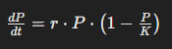
Where:
P is the population size at time T
r is the intrinsic growth rate of the population.
K is the carrying capacity of the environment.

Diode Equation
The diode equation is a nonlinear equation that describes the current-voltage relationship in a diode. It is essential for understanding and designing electronic circuits.
The diode equation is used to calculate the forward bias voltage of a diode in a circuit. The diode equation relates the voltage across a diode to the current passing through it, and it is given by:
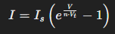
Where:
I is the diode current.
𝐼𝑠 is the saturation current.
𝑉 is the voltage across the diode.
𝑛 is the ideality factor (typically around 1 for silicon diodes).
𝑉𝑡 is the thermal voltage, approximately 26 mV at room temperature.

Rectangular Field Problem
The problem of finding the dimensions of a rectangular field given its perimeter and area is another practical application of nonlinear algebraic equations. It is used in urban planning and agriculture.
In a rectangle, the length (𝐿) and breadth (𝐵) are related to the area (𝐴)of the rectangle by the equation:
Perimeter:
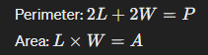
Where:
𝐿 is the length of the rectangle.
𝑊 is the width of the rectangle.
𝑃 is the given perimeter of the rectangle.
𝐴 is the given area of the rectangle.

Problem Solution
  - Logistic Growth:(Newton)
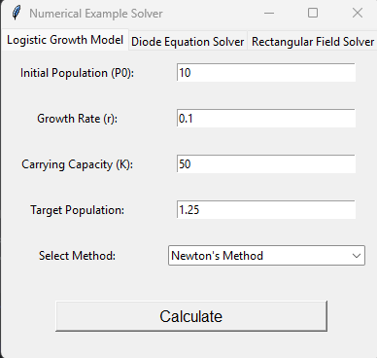
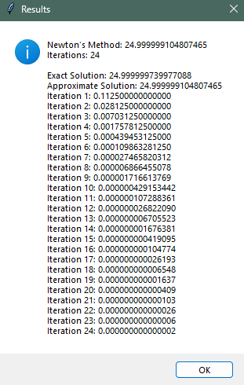

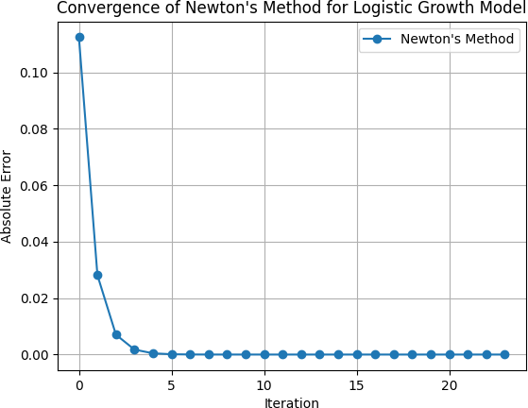

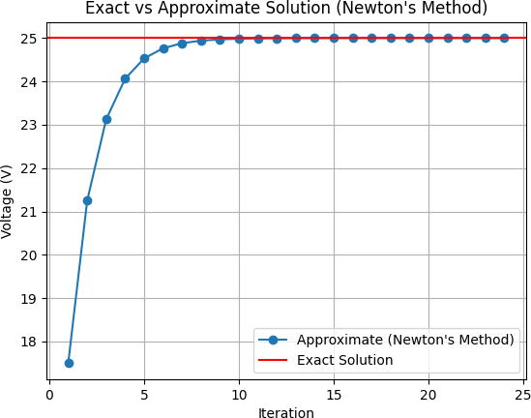

  - Logistic Growth:(Secant)
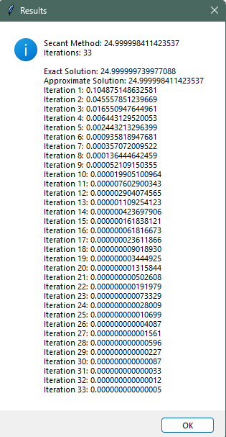

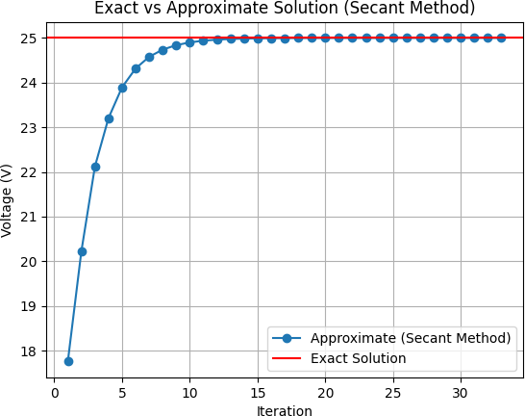

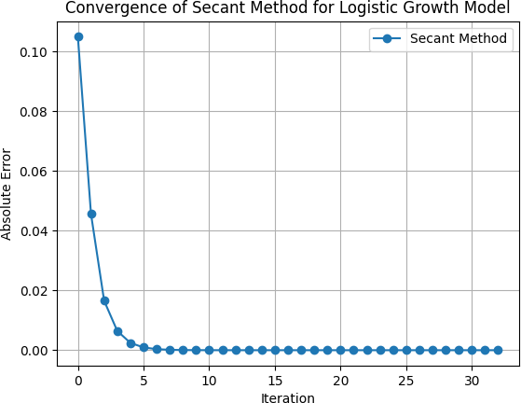

  - Logistic Growth:(Bisection)
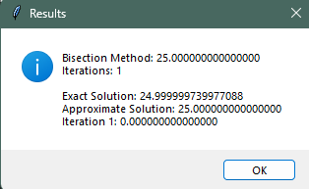

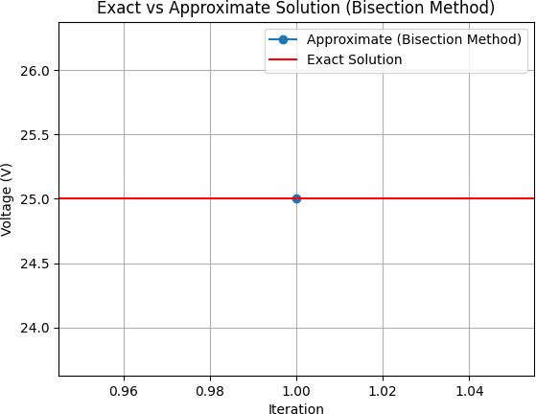

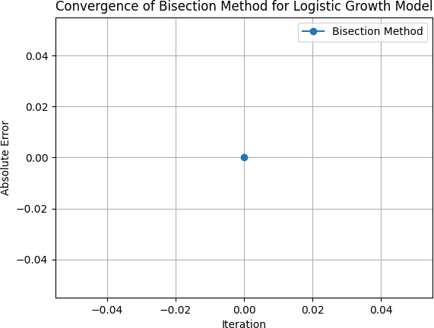

  - Diode Equation:(Newton)
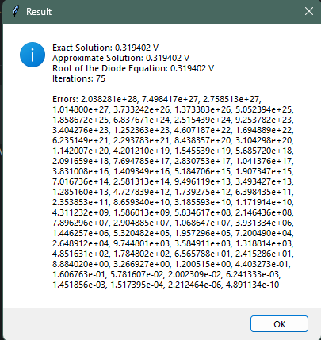

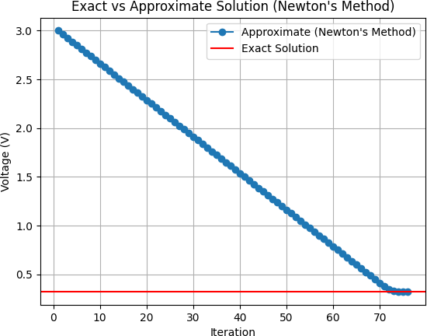

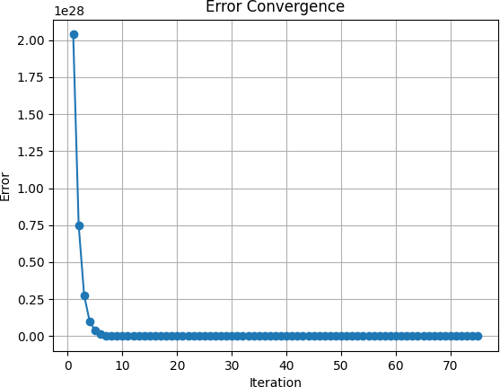

  - Diode Equation:(Bisection)

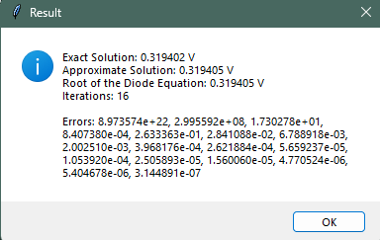

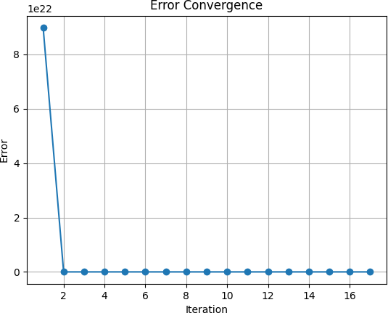

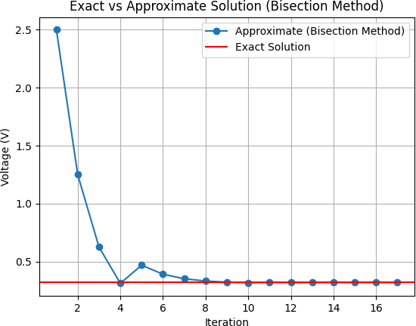

  - Diode Equation:(False Position)
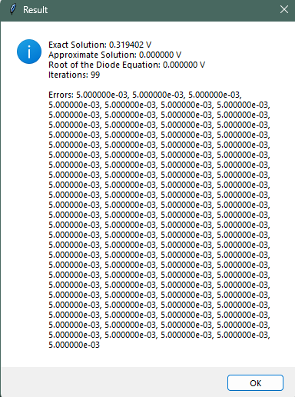

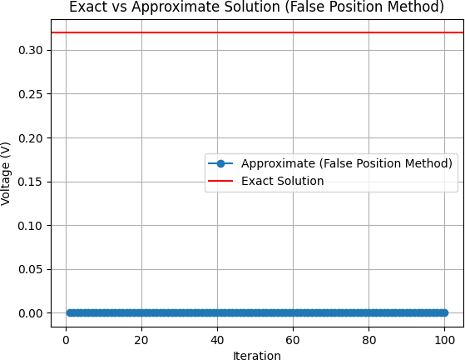

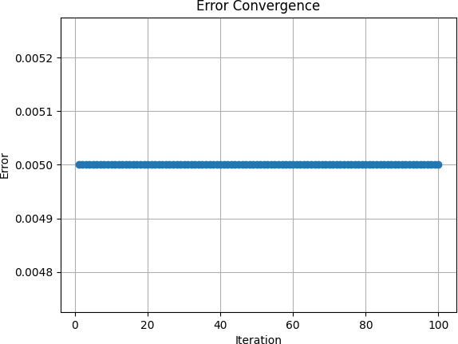

  - Rectangular Field:(Newton)
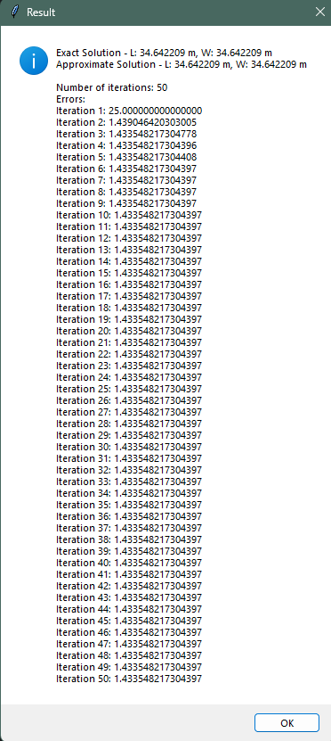

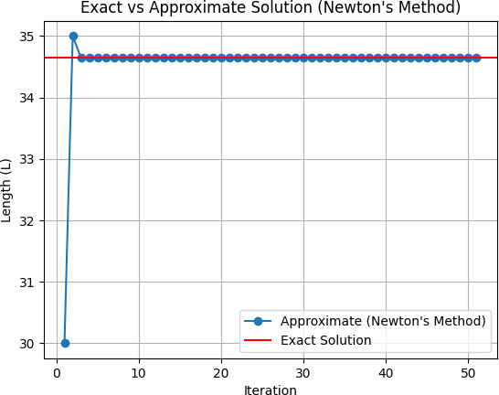

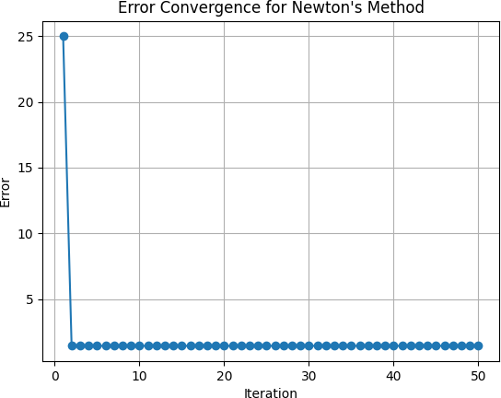

  - Rectangular Field:(Bisection)
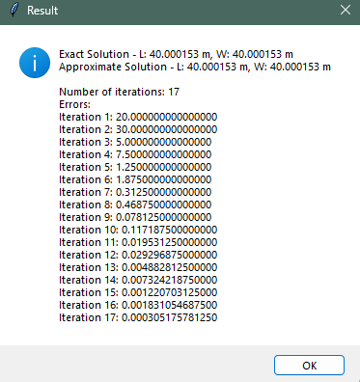

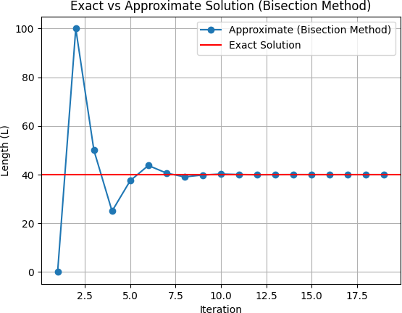

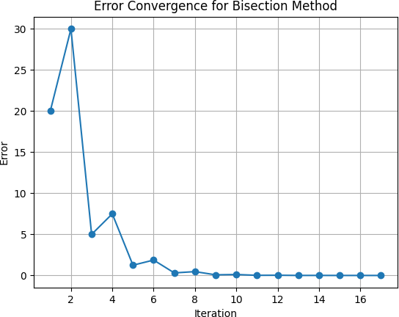

  - Rectangular Field:(Secant)
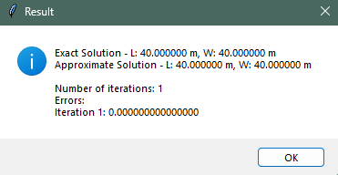

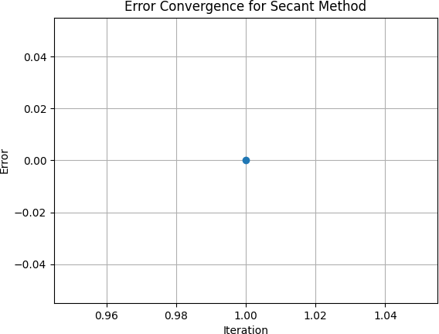

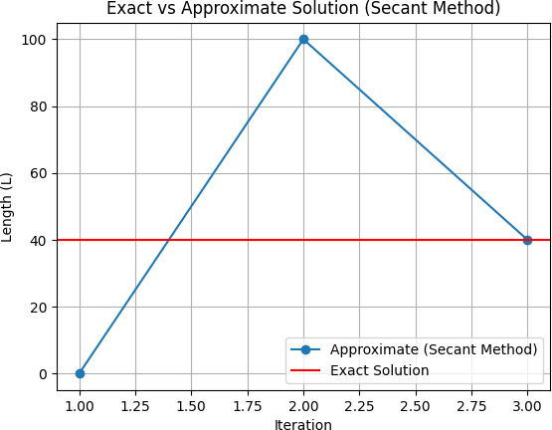

LOGISTIC GROWTH:

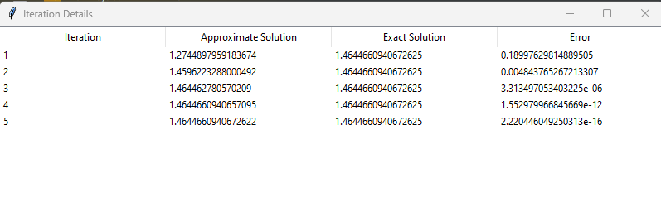

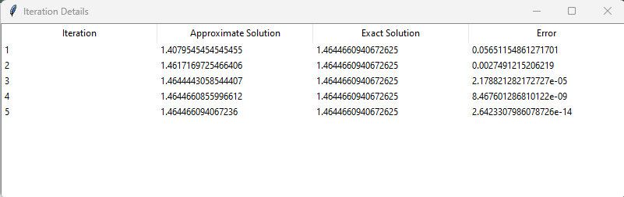

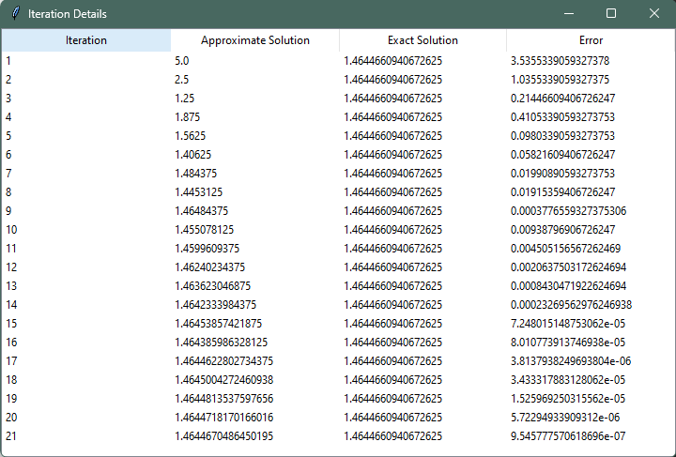
Diode-Equation:

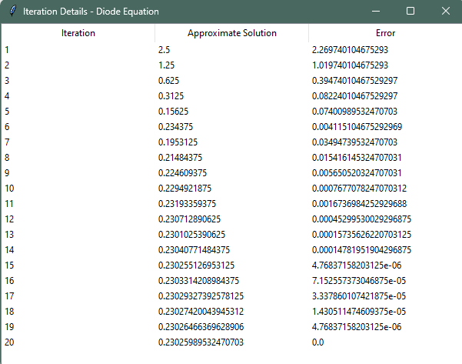

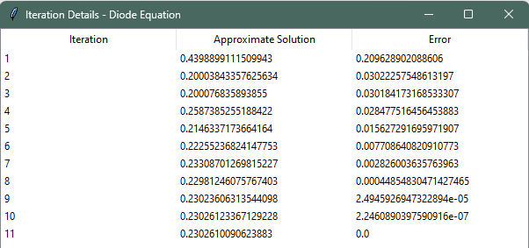
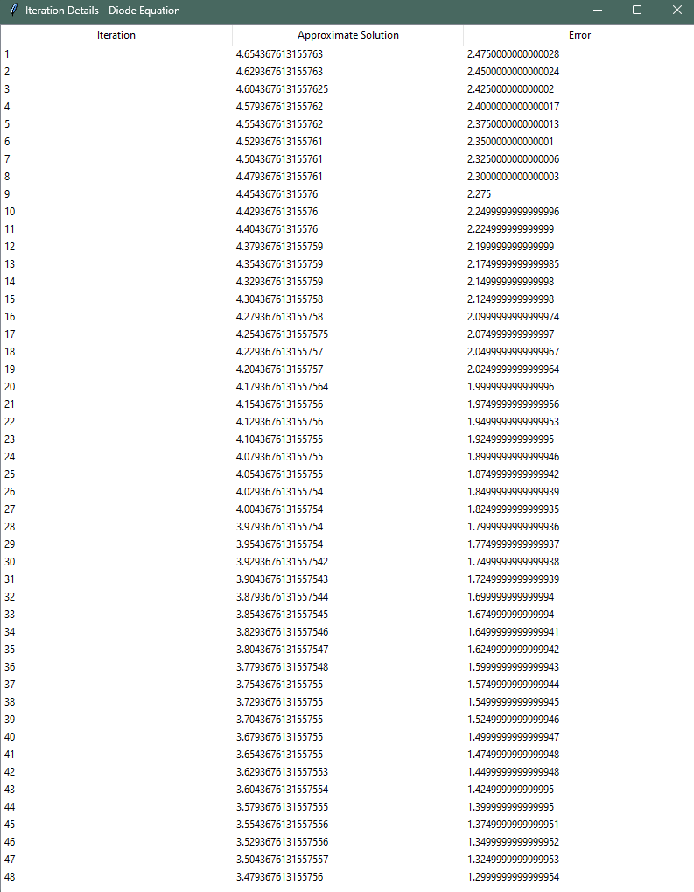

Rectangular- Field:

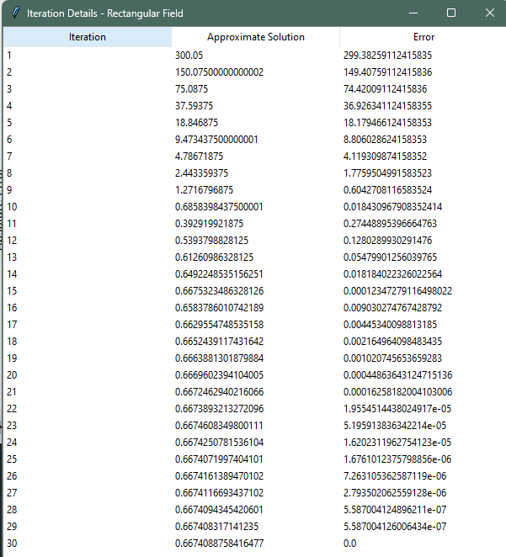

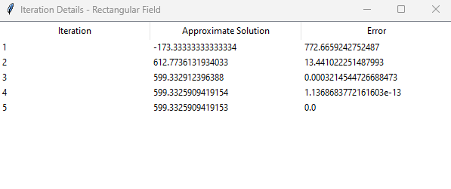

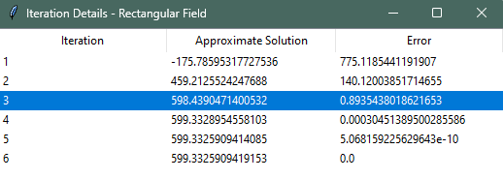

Result And Discussion

Comparison of Methods

The choice of numerical method depends on various factors such as the nature of the function, the desired level of accuracy, and the computational resources available. In this case, the Newton-Raphson method offers the fastest convergence but requires the computation of the derivative of the function, which may not always be straightforward. The Bisection method, while slower, is more robust and does not require derivative information. The Secant method offers a balance between speed and simplicity, making it a good choice for functions where the derivative is not readily available.

Discussion of Results

The results demonstrate the effectiveness of the Newton-Raphson, Bisection, and Secant methods in solving nonlinear equations. Each method has its advantages and limitations, and the choice of method should be based on the specific requirements of the problem at hand. In practice, it is often useful to use a combination of methods or to adapt the method based on the characteristics of the function being solved.

Conclusion
In conclusion, nonlinear algebraic equations play a crucial role in mathematical modeling and solving real-world problems. Understanding the theoretical concepts and numerical methods for solving these equations is essential for various fields of study. MATLAB and Python provide powerful tools for implementing and solving nonlinear equations, making them invaluable resources for researchers and practitioners alike.

References
- Remani, Courtney. "Numerical methods for solving systems of nonlinear equations." Lakehead University Thunder Bay, Ontario, Canada 77 (2013).
- Burden, R. L., & Faires, J. D. (2010). Numerical Analysis (9th ed.). Brooks Cole.
- Chapra, S. C., & Canale, R. P. (2010). Numerical Methods for Engineers (6th ed.). McGraw-Hill.
- Heath, M. T. (2002). Scientific Computing: An Introductory Survey (2nd ed.). McGraw-Hill.
- Kiusalaas, J. (2013). Numerical Methods in Engineering with Python 3. Cambridge University Press.
- Quarteroni, A., Sacco, R., & Saleri, F. (2010). Numerical Mathematics (2nd ed.). Springer.
- Trefethen, L. N., & Bau, D. (1997). Numerical Linear Algebra. SIAM

  - Appendices:
Logistic Growth Model:

function [root_newton_logistic, root_secant_logistic, root_bisection_logistic, x_vals_newton, x_vals_secant, x_vals_bisection] = logistic_growth_methods()
% Logistic Growth Parameters r = 0.1;
K = 50;
target_population = 1.25; % Target logistic growth rate P0 = 10;

% Newton's Method
[root_newton_logistic, ~, x_vals_newton] = newton_method(@f_logistic, @dfdx_logistic, P0, 1e-6, 100);

% Secant Method
[root_secant_logistic, ~, x_vals_secant] = secant_method(@f_logistic, P0, P0 + 1, 1e-6, 100);

% Bisection Method
[root_bisection_logistic, ~, x_vals_bisection] = bisection_method(@f_logistic, 0.0, K, 1e-6, 100);

% Nested Functions
function result = f_logistic(P)
result = logistic_growth(P, r, K) - target_population;
end

function result = dfdx_logistic(P) result = r * (1 - 2*P / K);
end

% Logistic Growth Model Function
function result = logistic_growth(P, r, K) result = r * P * (1 - P / K);
end
end

% Newton's Method
function [x, iterations, x_vals] = newton_method(f, dfdx, x0, tol, max_iter) x = x0;
x_vals = [x];
for iterations = 1:max_iter dx = -f(x) / dfdx(x); x = x + dx;
x_vals = [x_vals; x]; if abs(dx) < tol
break

end

end
end

% Secant Method
function [x, iterations, x_vals] = secant_method(f, x0, x1, tol, max_iter) x_vals = [x0; x1];
for iterations = 1:max_iter
dx = -f(x1) * (x1 - x0) / (f(x1) - f(x0)); x0 = x1;
x1 = x1 + dx;
x_vals = [x_vals; x1]; if abs(dx) < tol
break
end
end
x = x1; % Return the root found by the Secant method
end

% Bisection Method
function [x, iterations, x_vals] = bisection_method(f, a, b, tol, max_iter) x_vals = [];
for iterations = 1:max_iter c = (a + b) / 2; x_vals = [x_vals; c];
if abs(b - a) < tol || abs(f(c)) < tol break
elseif f(a) * f(c) < 0 b = c;
else
a = c;
end
end
x = c;
end

% Example Usage
[root_newton_logistic, root_secant_logistic, root_bisection_logistic, x_vals_newton, x_vals_secant, x_vals_bisection] = logistic_growth_methods();
disp(['Newton Root: ', num2str(root_newton_logistic)]); disp(['Secant Root: ', num2str(root_secant_logistic)]); disp(['Bisection Root: ', num2str(root_bisection_logistic)]);

% Plotting figure; subplot(3, 1, 1);
plot(1:size(x_vals_newton, 1), x_vals_newton, '-o'); title('Convergence of Newton''s Method'); xlabel('Iteration');
ylabel('Approximation'); grid on;

subplot(3, 1, 2);
plot(1:size(x_vals_secant, 1), x_vals_secant, '-o'); title('Convergence of Secant Method'); xlabel('Iteration');
ylabel('Approximation'); grid on;

subplot(3, 1, 3);
plot(1:size(x_vals_bisection, 1), x_vals_bisection, '-o'); title('Convergence of Bisection Method'); xlabel('Iteration');
ylabel('Approximation'); grid on;

Diode Equation:

function [root_newton_diode, root_bisection_diode, root_false_position_diode] = DiodeeSolver()
% Diode Equation Parameters Is = 1e-6;
n = 1.5;
Vt = 0.025;
V_guess = 3;

% Newton's Method for Diode Equation
[root_newton_diode, ~, ~, x_vals_newton] = newton_method(@f_diode, @dfdx_diode, V_guess, 1e-6, 100);

% Bisection Method for Diode Equation
[root_bisection_diode, ~, ~, x_vals_bisection] = bisection_method(@f_diode, 0.0, 5.0, 1e-6, 100);

% False Position (Regula Falsi) Method for Diode Equation [root_false_position_diode, ~, ~, x_vals_false_position] =
false_position_method(@f_diode, 0.0, 5.0, 1e-6, 100);

% Nested Functions
function result = f_diode(V)
result = Is * (exp(V / (n * Vt)) - 1) - 5 / 1000;
end

function result = dfdx_diode(V)
result = Is * exp(V / (n * Vt)) / (n * Vt);
end

% Plotting figure;

subplot(3, 1, 1);
plot(1:length(x_vals_newton), x_vals_newton, '-o', 'DisplayName', "Newton's Method"); xlabel('Iteration');
ylabel('Value of V');
title("Convergence of Newton's Method for Diode Equation"); legend('Location', 'best');

subplot(3, 1, 2);
plot(1:length(x_vals_bisection), x_vals_bisection, '-o', 'DisplayName', "Bisection Method");
hold on;
plot(1:length(x_vals_false_position), x_vals_false_position, '-o', 'DisplayName', "False Position Method");

xlabel('Iteration'); ylabel('Value of V');
title("Convergence of Bisection and False Position Methods for Diode Equation"); legend('Location', 'best');

subplot(3, 1, 3);
plot(1:length(x_vals_newton), x_vals_newton, '-o', 'DisplayName', "Newton's Method"); hold on;
plot(1:length(x_vals_bisection), x_vals_bisection, '-o', 'DisplayName', "Bisection Method");
plot(1:length(x_vals_false_position), x_vals_false_position, '-o', 'DisplayName', "False Position Method");
xlabel('Iteration'); ylabel('Value of V');
title("Convergence of Newton's, Bisection, and False Position Methods for Diode Equation");
legend('Location', 'best'); end
% Newton's Method
function [x, iterations, x_vals, root] = newton_method(f, dfdx, x0, tol, max_iter) x = x0;
x_vals = [x];
for iterations = 1:max_iter dx = -f(x) / dfdx(x); x = x + dx;
x_vals = [x_vals; x]; if abs(dx) < tol
break
end
end
root = x;
end

% Bisection Method
function [x, iterations, x_vals, root] = bisection_method(f, a, b, tol, max_iter) x_vals = [a; b];
for iterations = 1:max_iter c = (a + b) / 2; x_vals = [x_vals; c];
if abs(b - a) < tol || abs(f(c)) < tol break
elseif f(a) * f(c) < 0 b = c;
else
a = c;
end
end

end
x = c; root = x;

% False Position (Regula Falsi) Method

function [x, iterations, x_vals, root] = false_position_method(f, a, b, tol, max_iter)
x_vals = [a; b];
for iterations = 1:max_iter fa = f(a);
fb = f(b);
if abs(fb - fa) < 1e-10 % Check if denominator is close to zero break
end
c = (a * fb - b * fa) / (fb - fa); fc = f(c);
x_vals = [x_vals; c]; if abs(fc) < tol
break
end
if fa * fc < 0 b = c;
else
a = c;
end
end

end
x = c; root = x;

% Example Usage
[root_newton_diode, root_bisection_diode, root_false_position_diode] = DiodeeSolver();
disp(['Newton Root: ', num2str(root_newton_diode)]); disp(['Bisection Root: ', num2str(root_bisection_diode)]); disp(['False Position Root: ', num2str(root_false_position_diode)]);

Rectangular Field:

function RectangularField
% Given values perimeter_val = 140;
area_val = 1200;

% Exact solution
exact_length = sqrt(area_val); exact_width = exact_length;

fprintf('Exact Length of the rectangular field: %.6f m\n', exact_length); fprintf('Exact Width of the rectangular field: %.6f m\n\n', exact_width);

% Perimeter equation: 2L + 2W = P perimeter_eq = @(L, W) 2 * L + 2 * W;

% Area equation: L*W = A area_eq = @(L, W) L * W;

function [L, W, iterations] = secant_method(f, x0, x1, tol, max_iter) for iterations = 1:max_iter
fx1 = f(x1);

fx0 = f(x0);
x_new = x1 - (fx1 * (x1 - x0)) / (fx1 - fx0); if abs(x_new - x1) < tol
break;

end
end
x0 = x1; x1 = x_new;

L = x_new; W = x_new;
end

function [L, W, iterations] = bisection_method(f, a, b, tol, max_iter) for iterations = 1:max_iter
c = (a + b) / 2; if f(a) * f(c) < 0
b = c;

else

end

a = c;

if abs(b - a) < tol break;
end
end
L = c;
W = c;
end

% Solve using Secant method
[L_secant, W_secant, iterations_secant] = secant_method(@(L) perimeter_eq(L, 30)
- perimeter_val, 0, 100, 1e-3, 100);
[L_bisection, W_bisection, iterations_bisection] = bisection_method(@(L) perimeter_eq(L, 30) - perimeter_val, 0, 100, 1e-3, 100);

% Print results
fprintf('Length of the rectangular field (Secant method): %.6f m\n', L_secant); fprintf('Width of the rectangular field (Secant method): %.6f m\n', W_secant); fprintf('Number of iterations for Secant method: %d\n\n', iterations_secant);

fprintf('Length of the rectangular field (Bisection method): %.6f m\n', L_bisection);
fprintf('Width of the rectangular field (Bisection method): %.6f m\n', W_bisection);
fprintf('Number of iterations for Bisection method: %d\n\n', iterations_bisection);

% Calculate errors
error_length_secant = abs(L_secant - exact_length); error_width_secant = abs(W_secant - exact_width); error_length_bisection = abs(L_bisection - exact_length); error_width_bisection = abs(W_bisection - exact_width);

fprintf('Error in Length (Secant): %.6f m\n', error_length_secant); fprintf('Error in Width (Secant): %.6f m\n\n', error_width_secant);

fprintf('Error in Length (Bisection): %.6f m\n', error_length_bisection); fprintf('Error in Width (Bisection): %.6f m\n\n', error_width_bisection);

% Plotting figure;
plot(1:iterations_secant+1, [exact_length*ones(1, iterations_secant+1); exact_width*ones(1, iterations_secant+1)], 'k--', 'DisplayName', 'Exact');
hold on;
plot(1:iterations_secant+1, [L_secant*ones(1, iterations_secant+1); W_secant*ones(1, iterations_secant+1)], '-o', 'DisplayName', 'Secant');
xlabel('Iteration'); ylabel('Value');
title('Convergence of Secant Method for Rectangular Field'); legend('Location', 'best');
grid on; hold off;

figure;
plot(1:iterations_bisection+1, [exact_length*ones(1, iterations_bisection+1); exact_width*ones(1, iterations_bisection+1)], 'k--', 'DisplayName', 'Exact');
hold on;
plot(1:iterations_bisection+1, [L_bisection*ones(1, iterations_bisection+1); W_bisection*ones(1, iterations_bisection+1)], '-o', 'DisplayName', 'Bisection');
xlabel('Iteration'); ylabel('Value');
title('Convergence of Bisection Method for Rectangular Field'); legend('Location', 'best');
grid on; hold off;
end

LOGISTIC GROWTH GRAPH(MATLAB):
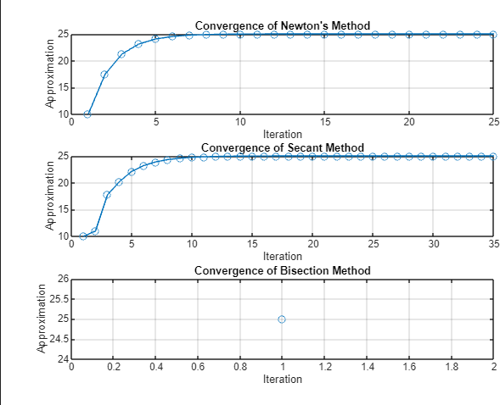
Diode Equation Graph (MATLAB):

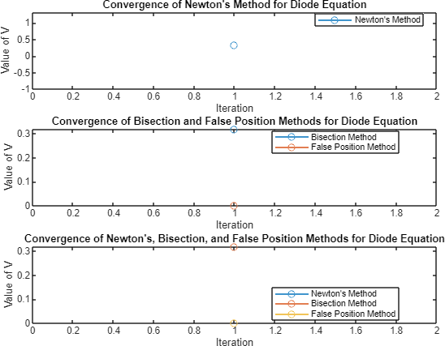

Rectangular Field Graph(MATLAB):
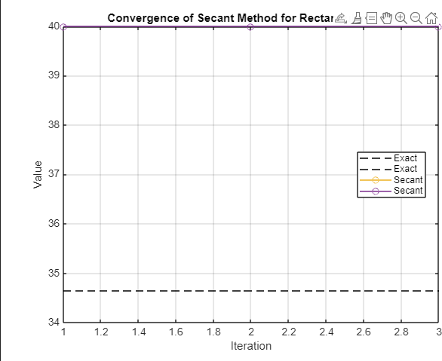
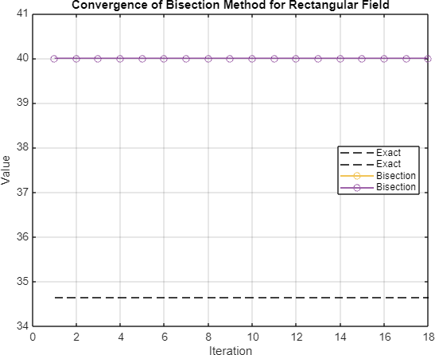

    - Python Code

Logistic Growth Python Code:
import numpy as np
import matplotlib.pyplot as plt

def logistic_growth(P, r, K): return r * P * (1 - P / K)

def newton_method(f, dfdx, x0, tol=1e-6, max_iter=100): x = x0
x_vals = [] errors = []
for i in range(max_iter):
dx = -f(x) / dfdx(x) x += dx x_vals.append(x)
errors.append(np.abs(dx)) if np.abs(dx) < tol:
break
return x, i+1, x_vals, errors

def secant_method(f, x0, x1, tol=1e-6, max_iter=100): x_prev = x0
x = x1 x_vals = [] errors = []
for i in range(max_iter):
dx = -f(x) * (x - x_prev) / (f(x) - f(x_prev))

x_prev = x x += dx
x_vals.append(x) errors.append(np.abs(dx)) if np.abs(dx) < tol:
break
return x, i+1, x_vals, errors

def bisection_method(f, a, b, tol=1e-6, max_iter=100): x_vals = []
errors = []
for i in range(max_iter):
c = (a + b) / 2 x_vals.append(c) fc = f(c)
if np.abs(fc) < tol or (b - a) / 2 < tol:
break
elif f(a) * fc < 0: b = c
else:
a = c errors.append(np.abs(b - a))
if not errors: # Check if errors list is empty
print("Bisection method did not converge within the maximum number of iterations") return c, i+1, x_vals, errors

# Example 2: Logistic Growth Model r = 0.1
K = 50

target_population = 1.25 # Target logistic growth rate P0 = 10

def f_logistic(P):
return logistic_growth(P, r, K) - target_population

def dfdx_logistic(P): return r * (1 - 2*P / K)

# Newton's method for Logistic Growth Model
root_newton_logistic, newton_iterations, newton_vals, newton_errors = newton_method(f_logistic, dfdx_logistic, P0)
print("Newton's method (Logistic Growth Model):", root_newton_logistic) print("Newton's method iterations:", newton_iterations)
print("Newton's method error:", newton_errors[-1]) # Print final error

# Secant method for Logistic Growth Model
root_secant_logistic, secant_iterations, secant_vals, secant_errors = secant_method(f_logistic, P0, P0 + 1)
print("Secant method (Logistic Growth Model):", root_secant_logistic) print("Secant method iterations:", secant_iterations)
print("Secant method error:", secant_errors[-1]) # Print final error

# Bisection method for Logistic Growth Model
root_bisection_logistic, bisection_iterations, bisection_vals, bisection_errors = bisection_method(f_logistic, 0.0, K)
print("Bisection method (Logistic Growth Model):", root_bisection_logistic) print("Bisection method iterations:", bisection_iterations)
if bisection_errors: # Check if the errors list is not empty
print("Bisection method error:", bisection_errors[-1]) # Print final error

# Plotting for Logistic Growth Model P_range = np.linspace(0, K, 100) P_growth = logistic_growth(P_range, r, K)

plt.figure()
plt.plot(P_range, P_growth, label='Logistic Growth Model')
plt.scatter(root_newton_logistic, logistic_growth(root_newton_logistic, r, K), color='r', label="Newton's method")
plt.scatter(root_secant_logistic, logistic_growth(root_secant_logistic, r, K), color='g', label="Secant method")
plt.scatter(root_bisection_logistic, logistic_growth(root_bisection_logistic, r, K), color='b', label="Bisection method")
plt.xlabel('Population size') plt.ylabel('Growth rate')
plt.title('Logistic Growth Model Analysis') plt.legend()
plt.grid(True) plt.show()

# Plotting convergence graphs plt.figure(figsize=(10, 6))

# Plot for Newton's method
plt.plot(newton_errors, label="Newton's method", color='r')

# Plot for Secant method
plt.plot(secant_errors, label="Secant method", color='g')

# Plot for Bisection method

if bisection_errors: # Check if the errors list is not empty plt.plot(bisection_errors, label="Bisection method", color='b')

plt.xlabel('Iteration') plt.ylabel('Absolute Error')
plt.title('Convergence of Different Methods for Logistic Growth Model') plt.legend()
plt.grid(True) plt.show()

Diode Equation Code:
import numpy as np
import matplotlib.pyplot as plt

# Diode Equation Parameters Is = 1e-6
n = 1.5
Vt = 0.025
V_guess = 3

# Function for Diode Equation
def diode_equation(V, Is, n, Vt, I_load): return Is * (np.exp(V / (n * Vt)) - 1) - I_load

# Derivative of the Diode Equation
def diode_equation_derivative(V, Is, n, Vt): return Is * np.exp(V / (n * Vt)) / (n * Vt)

# Newton's method

def newton_method(f, dfdx, x0, Is, n, Vt, I_load, tol=1e-6, max_iter=100): x = x0
x_vals = [x]
for _ in range(max_iter):
dx = -f(x, Is, n, Vt, I_load) / dfdx(x, Is, n, Vt) x += dx
x_vals.append(x) if np.abs(dx) < tol:
break
return x, x_vals, len(x_vals) - 1

# Bisection method
def bisection_method(f, a, b, Is, n, Vt, I_load, tol=1e-6, max_iter=100): x_vals = []
for _ in range(max_iter):
c = (a + b) / 2.0
fc = f(c, Is, n, Vt, I_load) x_vals.append(c)
if np.abs(fc) < tol:
break
if f(a, Is, n, Vt, I_load) * fc < 0:
b = c else:
a = c
return c, x_vals, len(x_vals) - 1

# False Position (Regula Falsi) method
def false_position_method(f, a, b, Is, n, Vt, I_load, tol=1e-6, max_iter=100): x_vals = []

for _ in range(max_iter):
fa = f(a, Is, n, Vt, I_load) fb = f(b, Is, n, Vt, I_load)
if np.abs(fb - fa) < 1e-10: # Check if denominator is close to zero break
c = (a * fb - b * fa) / (fb - fa) fc = f(c, Is, n, Vt, I_load) x_vals.append(c)
if np.abs(fc) < tol:
break
if fa * fc < 0:
b = c else:
a = c
return c, x_vals, len(x_vals) - 1

# Calculate the current in the circuit R = 1000 # Resistance in ohms I_load = 5 / R

# Calculate the forward bias voltage using Newton's method
root_newton_diode, x_vals_newton, iterations_newton = newton_method(diode_equation, diode_equation_derivative, V_guess, Is, n, Vt, I_load)

# Calculate the forward bias voltage using the bisection method
root_bisection_diode, x_vals_bisection, iterations_bisection = bisection_method(diode_equation, 0.0, 5.0, Is, n, Vt, I_load)

# Calculate the forward bias voltage using the false position method

root_false_position_diode, x_vals_false_position, iterations_false_position = false_position_method(diode_equation, 0.0, 5.0, Is, n, Vt, I_load)

# Print the results
print("\nDiode Equation Parameters:") print(f"Is: {Is}")
print(f"n: {n}")
print(f"Vt: {Vt}\n")

print(f"Root of the Diode Equation (Newton's method): {root_newton_diode:.6f} V") print(f"Number of iterations for Newton's method: {iterations_newton}\n")

print(f"Root of the Diode Equation (Bisection method): {root_bisection_diode:.6f} V") print(f"Number of iterations for Bisection method: {iterations_bisection}\n")

print(f"Root of the Diode Equation (False Position method): {root_false_position_diode:.6f} V") print(f"Number of iterations for False Position method: {iterations_false_position}\n")

# Calculate errors
error_newton = np.abs(root_newton_diode - Vt * np.log(I_load / Is + 1)) error_bisection = np.abs(root_bisection_diode - Vt * np.log(I_load / Is + 1)) error_false_position = np.abs(root_false_position_diode - Vt * np.log(I_load / Is + 1))

print(f"Error in Root (Newton): {error_newton:.6f} V") print(f"Error in Root (Bisection): {error_bisection:.6f} V") print(f"Error in Root (False Position): {error_false_position:.6f} V")

# Plotting convergence plt.figure(figsize=(10, 6))

# Plot for Newton's method
plt.plot(np.abs(x_vals_newton - root_newton_diode), label="Newton's method")

# Plot for Bisection method
plt.plot(range(len(x_vals_bisection)), np.abs(np.array(x_vals_bisection) - root_bisection_diode), label="Bisection method")

# Plot for False Position method
plt.plot(range(len(x_vals_false_position)), np.abs(np.array(x_vals_false_position) - root_false_position_diode), label="False Position method")

plt.xlabel('Iteration') plt.ylabel('Absolute Error')
plt.title('Convergence of Different Methods for Diode Equation') plt.legend()
plt.grid(True) plt.show()

Rectangular Field Python Code:
import numpy as np
import matplotlib.pyplot as plt

# Given values perimeter_val = 140
area_val = 1200

# Exact solution
exact_length = np.sqrt(area_val)

exact_width = exact_length

print(f"Exact Length of the rectangular field: {exact_length:.6f} m") print(f"Exact Width of the rectangular field: {exact_width:.6f} m")

# Perimeter equation: 2L + 2W = P def perimeter_eq(L, W):
return 2 * L + 2 * W

# Area equation: L*W = A def area_eq(L, W):
return L * W

def solve_rectangular_field(perimeter_val, area_val): # Initial guess
L0 = 30.0

def f(L, W):
return np.array([perimeter_eq(L, W) - perimeter_val, area_eq(L, W) - area_val])

def dfdx(L, W):
return np.array([[2, 2], [W, L]])

def newton_method(f, dfdx, x0, tol=1e-3, max_iter=100): x = x0.astype(float) # Ensure x is a float array
x_vals = [x]
for i in range(1, max_iter+1):
dx = np.linalg.lstsq(dfdx(*x), -f(*x), rcond=None)[0] x += dx

x_vals.append(x)
if np.linalg.norm(dx) < tol:
break return x, x_vals, i

def bisection_method(f, a, b, tol=1e-3, max_iter=100):
x_vals = [a, b]
for i in range(1, max_iter+1):
c = (a + b) / 2 x_vals.append(c) if f(a) * f(c) < 0:
b = c else:
a = c
if np.abs(b - a) < tol:
break return c, x_vals, i

# Solve using all three methods
L_newton, x_vals_newton, iterations_newton = newton_method(f, dfdx, np.array([L0, L0])) L_bisection, x_vals_bisection, iterations_bisection = bisection_method(lambda L: f(L, L0)[0], 0, 100)

return L_newton, L_secant, L_bisection, iterations_newton, iterations_secant, iterations_bisection

# Solve the system of equations
L_newton, L_secant, L_bisection, iterations_newton, iterations_secant, iterations_bisection = solve_rectangular_field(perimeter_val, area_val)

# Print results
print(f"\nLength of the rectangular field (Newton's method): {L_newton[0]:.6f} m") print(f"Width of the rectangular field (Newton's method): {L_newton[1]:.6f} m") print(f"Number of iterations for Newton's method: {iterations_newton}")

print(f"\nLength of the rectangular field (Bisection method): {L_bisection:.6f} m") print(f"Width of the rectangular field (Bisection method): {L_bisection:.6f} m") print(f"Number of iterations for Bisection method: {iterations_bisection}")

# Calculate errors
error_length_newton = np.abs(L_newton[0] - exact_length) error_width_newton = np.abs(L_newton[1] - exact_width) error_length_bisection = np.abs(L_bisection - exact_length) error_width_bisection = np.abs(L_bisection - exact_width)

print(f"\nError in Length (Newton): {error_length_newton:.6f} m") print(f"Error in Width (Newton): {error_width_newton:.6f} m") print(f"\nError in Length (Bisection): {error_length_bisection:.6f} m") print(f"Error in Width (Bisection): {error_width_bisection:.6f} m")

plt.figure(figsize=(10, 6))

# Plot for Newton's method
plt.semilogy(range(len(x_vals_newton)), np.linalg.norm(np.array(x_vals_newton) - L_newton, axis=1), label="Newton's method")

# Plot for Bisection method
plt.semilogy(range(len(x_vals_bisection)), np.abs(np.array(x_vals_bisection) - L_bisection), label="Bisection method")

plt.xlabel('Iteration') plt.ylabel('Absolute Error')
plt.title('Convergence of Different Methods for Rectangular Field Problem') plt.legend()
plt.grid(True) plt.show()

